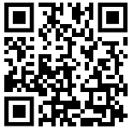
Assessing Risk
The process of Risk Assessment
Scan the QR code to watch the video and answer the following questions.
https://tinyurl.com/8c3cmhc8
Scenario 1 – Trapped Fingers
What object or action, or feature OF an object or action, might cause an injury ?
What might happen to the person – think about in what way they may get hurt or injured.
Who is at risk ? | The Children Visitors  Everyone The Adults
On a scale of 1 to 5, how severe might this be ?
On a scale of 1 to 5, how likely is it to happen ?
What has been done to prevent this accident taking place ?
Scenario 2 – Wet Floor
What object or action, or feature OF an object or action, might cause an injury ?
What might happen to the person – think about in what way they may get hurt or injured.
Who is at risk ? | The Children Visitors  Everyone The Adults
On a scale of 1 to 5, how severe might this be ?
On a scale of 1 to 5, how likely is it to happen ?
What has been done to prevent this accident taking place ?

Scenario 3 – Chair Not Pushed In
What object or action, or feature OF an object or action, might cause an injury ?
What might happen to the person – think about in what way they may get hurt or injured.
Who is at risk ? | The Children Visitors  Everyone The Adults
On a scale of 1 to 5, how severe might this be ?
On a scale of 1 to 5, how likely is it to happen ?
What has been done to prevent this accident taking place ?

Scenario 4 – Baby Left Unattended
What object or action, or feature OF an object or action, might cause an injury ?
What might happen to the person – think about in what ways they may get hurt or injured.
Who is at risk ? | The Children Visitors  Everyone The Adults
On a scale of 1 to 5, how severe might this be ?
On a scale of 1 to 5, how likely is it to happen ?
What has been done to prevent this accident taking place ?

Scenario 5 – Gate left Open
What object or action, or feature OF an object or action, might cause an injury ?
What might happen to the person – think about in what ways they may get hurt or injured.
Who is at risk ? | The Children Visitors  Everyone The Adults
On a scale of 1 to 5, how severe might this be ?
On a scale of 1 to 5, how likely is it to happen ?
What has been done to prevent this accident taking place ?

Scenario 6 – Allergy Ignored
What object or action, or feature OF an object or action, might cause an injury ?
What might happen to the person – think about in what ways they may get hurt or injured.
Who is at risk ? | The Children Visitors  Everyone The Adults
On a scale of 1 to 5, how severe might this be ?
On a scale of 1 to 5, how likely is it to happen ?
What has been done to prevent this accident taking place ?

Scenario 7 – Dettox Left Out
What object or action, or feature OF an object or action, might cause an injury ?
What might happen to the person – think about in what ways they may get hurt or injured.
Who is at risk ? | The Children Visitors  Everyone The Adults
On a scale of 1 to 5, how severe might this be ?
On a scale of 1 to 5, how likely is it to happen ?
What has been done to prevent this accident taking place ?

Scenario 8 – Cot Side Not Raised
What object or action, or feature OF an object or action, might cause an injury ?
What might happen to the person – think about in what ways they may get hurt or injured.
Who is at risk ? | The Children Visitors  Everyone The Adults
On a scale of 1 to 5, how severe might this be ?
On a scale of 1 to 5, how likely is it to happen ?
What has been done to prevent this accident taking place ?

Scenario 9 – Hot drink at child height
What object or action, or feature OF an object or action, might cause an injury ?
What might happen to the person – think about in what ways they may get hurt or injured.
Who is at risk ? | The Children Visitors  Everyone The Adults
On a scale of 1 to 5, how severe might this be ?
On a scale of 1 to 5, how likely is it to happen ?
What has been done to prevent this accident taking place ?

Scenario 10 – Tools left out
What object or action, or feature OF an object or action, might cause an injury ?
What might happen to the person – think about in what ways they may get hurt or injured.
Who is at risk ? | The Children Visitors  Everyone The Adults
On a scale of 1 to 5, how severe might this be ?
On a scale of 1 to 5, how likely is it to happen ?
What has been done to prevent this accident taking place ?

Scenario 11 – Children Not Secured
What object or action, or feature OF an object or action, might cause an injury ?
What might happen to the person – think about in what ways they may get hurt or injured.
Who is at risk ? | The Children Visitors  Everyone The Adults
On a scale of 1 to 5, how severe might this be ?
On a scale of 1 to 5, how likely is it to happen ?
What has been done to prevent this accident taking place ?

What object or action, or feature OF an object or action, might cause an injury ? | This is the thing or action that presents a danger to the person.  This is the HAZARD
What might happen to the person – think about in what ways they may get hurt or injured. | This is what might happen to a person because of the HAZARD  This is the RISK
Who is at risk ? | The Children Visitors  Everyone The Adults
On a scale of 1 to 5, how severe might this be ? 1 is a minor injury and 5 is death or life changing injuries | SEVERITY  This is how serious any injury might be. Is it likely to result in a bruise … or might the person die as a result of the hazard ?
On a scale of 1 to 5, how likely is it to happen ? 1 is likely to happen and 5 is highly unlikely. | This is how likely to happen an accident arising from the hazard is.  LIKELIHOOD
What has been done to prevent this accident taking place ? | This is a list of all the things that are already in place to reduce the chances of accident relating to the specific hazard.  EXISTING CONTROLS
Risk Assessment Terminology

The Risk Assessment Form
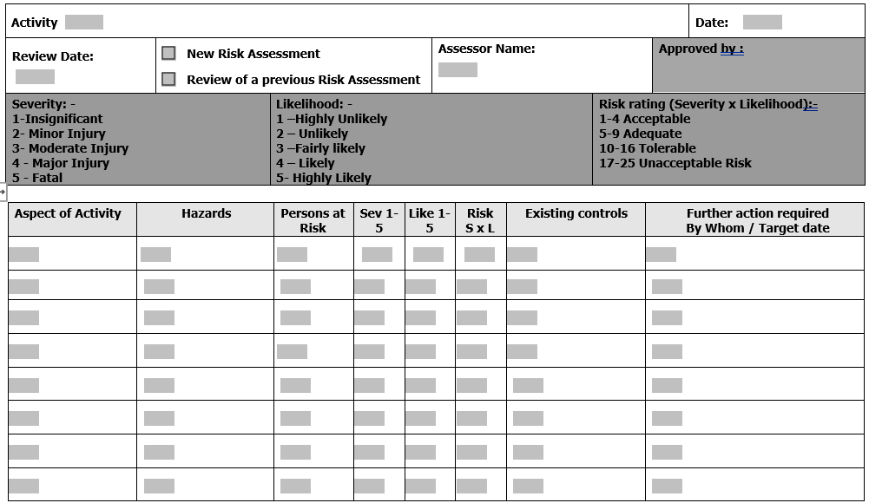
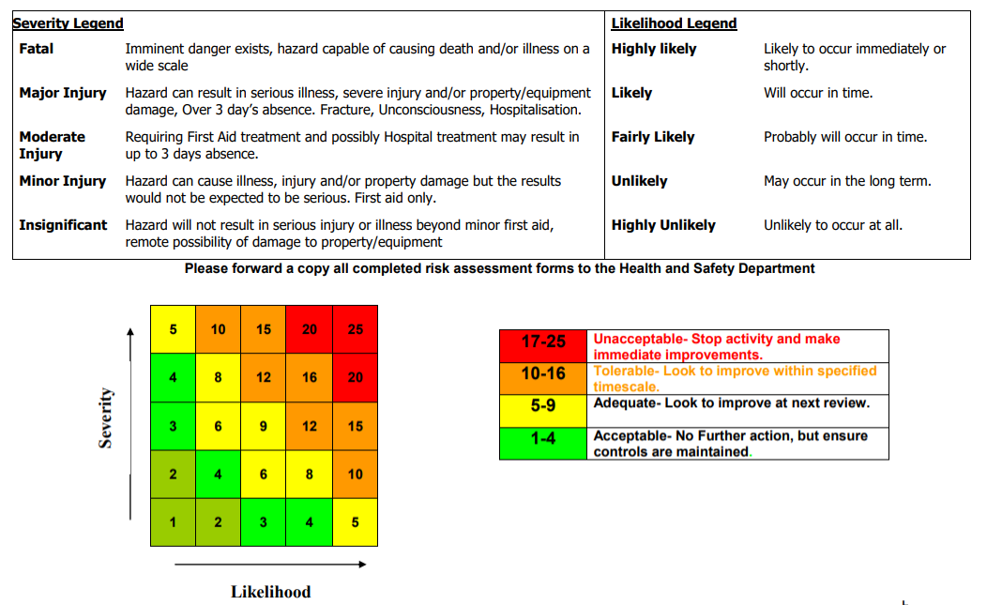
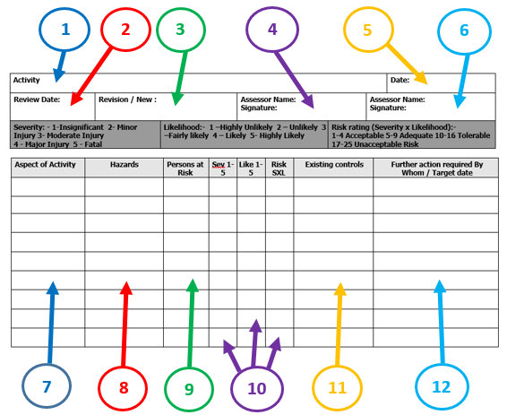
Completing the Risk Assessment Form
- So, for each of these aspects, what might the hazards be? Walking along a main road? The hazard might be a child stepping off the path onto the road. Taking packed lunches? The hazard might be that someone might bring a peanut butter sandwich, and one of the group is severely allergic to peanuts.
- For each aspect, who is at risk? This might be just one person, a few people, or the whole group.
- For each aspect, on a scale of 1 to 5, how likely is it to happen, and, on a scale of 1 to 5, how severe might it be if it did happen? Finally … multiply to two numbers together then look at the grid on page 2 of the risk assessment form to see if the risk is acceptable.
- For each aspect, what steps are already in place to reduce the risk?
- For each aspect, what do we need to do to reduce risk, who is responsible for ensuring this is done, and by when?
- The general activity. Example – “Measuring Trees”
- The review date is when this risk assessment will be reviewed. This is useful if activities are to be repeated or are ongoing. Risk is dynamic, meaning that it can change over time, and may change if different people are participating. The frequency of review is dependent on the activity and the participants.
- Is this a ‘revised’ risk assessment, or a new risk assessment?
- The name of the person completing the risk assessment form.
- The date the risk assessment was created.
- The name of the person who will approve the risk assessment.
- Within each activity there will be aspects which each need risk assessed. Examples might be … How are the children travelling to a location? What steps will you take to ensure you can contact help in the event of an incident? Does anyone in the group have any medical conditions to be aware of?

Risk assessment is a hugely important aspect of most areas or work.
Only by carefully assessing the ways in which accidents might occur, and considering steps that can be taken to reduce the chances of that accident taking place can we be sure that the place of work, or the activity being undertaken, is safe.
You would never, we would hope, walk out onto a road without checking it is safe.
You would never, we would hope, climb a ladder that was not secure.
You would never, we would hope, store chemicals in a cupboard that children had access to.
You would never, we would hope, leave a hot iron in reach of a young child.

For the most part, Risk Assessment is all about common sense.
What is does NOT mean, however, is that we ‘wrap children in cotton wool’ and remove all and any risk from the environment.
Children need to learn about danger, and how to stay safe, and so, while we should always be making sure they are safe, it is important that we DO let them learn through play.
This part of your timetable focusses on Outdoor learning, and STEM (Science, Technology, Engineering and Maths). We WILL do some activities that involve a degree of risk, but we will manage the risk.
You will be reminded about wearing appropriate clothing. You will be reminded about uneven ground when we are walking through wooded areas. You will be advised to tie your hair back when we are lighting fires. You will be reminded that smores can be very hot. Some of these things will be blindingly obvious to you … others will not.
Risk assessment is about a common sense approach to managing situations that could be dangerous.

What if we don’t bother about risk assessments ?
If you put a child (or any person in your care, including members of the staff team) in danger, and you cannot evidence that you have considered the possible risks, then you could …
- Lose your job
- Lose your registration with the SSSC or whatever body you are registered with, meaning you can no longer work in care.
- Be prosecuted.
- Go to prison.
And, at the end of the day, if a child has died as a result of your negligence, then that will be something that you will probably never be able to forgive yourself for.

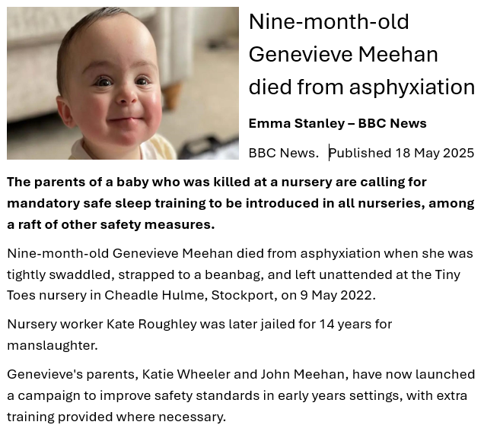

Full story available at https://www.bbc.com/news/articles/c9wgpdpdedqo

